Light formatting 7x2 sets of triples

Dark formatting 6x2 sets of triples. T20 plus another gray plus the missing pink, teal, yellow

To make the dark formatting

Take the 20. Split into pairs. Then interpolate the middle one. Then we need to add the missing 10’s, and change the middle purple to the purple in the 10’s (should probably just make this so)

Grays

**Left column**

     #000000

     #1b1b1b

F9 #333333

     #555555

F8 #666666

     #898989

**Right column**

      #ffffff

F2 #f5f5f5

F3 #e6e6e6

F5 #d4d4d4

     #c0c0c0

F7 #b4b4b4

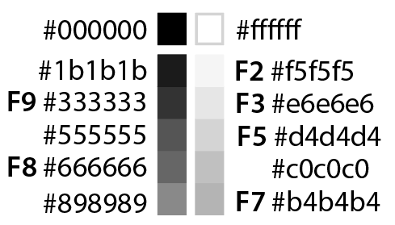

To deliver palettes

* Add Shahaf’s format.
* Create clear list of replacements (upgrades), additions, deletions
  + Categoricals
  + Quantitative
  + Multi-ordinals
  + Formatting
* Create and approve the colors.

To evaluate colors

For any palette, create the distribution of distances.

* For each color, compute DE94 to each other color. Also ND50 for 3 sizes.
* This will be N!/2 values. D1-2, D1-3, etc. Sort all D’s, print out c1, c2, D
* Give each color an ID#, overplot on the bars. Sort by D from selected.
* For any color, there is a min and max D with respect to the palettes. Overplot with these values.
* Sort by minimum D
* Create a DE profile for any given order.
* Some sort of concise “profile” DL range, DL uniformity

Compare similar palettes

* Read in XML, create combined palette with duplicates represented only once.
* Things one might want to know
  + Identical colors
  + Very similar colors
* Make two palettes have the same “order” (can we do this?)

Split and combine palettes

* Use the L* range as a filter for the colors, as well as for the view.
* Note the L* range filter isn’t being applied to the ab plot. It should be.
* Is it worth taking the time to create hue/chroma filters?